Tatevik Azoyan
August 13, 2024

Executive Summary

Feature Name | File Upload
Product Area | Project Page
User Persona/ Story | All Haibrid users.  As a user, I would like to have the ability to upload files (All main file types should be supported, similar to Jira attachment functionality - images (png, jpg, jpeg), .docx, .pdf, .xlsx, .pptx, .mov, MP4, MP3, etc.), with the ability to edit, preview, and remove.
Description | Overview  File upload will allow users to store, share, and quickly retrieve a variety of information sources within selected workspace and projects and quickly retrieve them.  Key Features  - File upload  - File preview  - File download
User Problem | Currently users are limited to saving texts only, in the form of web URLs. However, people often have important PDFs, presentations, images, videos, etc. that completes their knowledge base related to a specific topic or project.  Some of the interviewees who mentioned they would like the ability to upload PDFs and other files:  - Anna Tsaturyan (One of her key problems is working with a mix of online sources and pdf files she has downloaded, they have lots of external reports they use for their work which is in the form of pdf files they download)  - Jinhong Yuan (Most of his sources are pdfs and slides)  - Joe Barhouch (A lot of the research content he consumes is in the form of pdfs)  - Lori Youmshajekian (Would like a commenting feature on top of pdfs)  - Albert Aharonian (Would need the option to upload pdfs to include Haibrid into his workflow)  - Levon Sevunts (Would like to be able to share annotated pdfs indicating what was useful within the pdfs)  - Johannes Ruf (Would like the app to save pdfs when browsing in a similar way as saving standard webpages+ Would like to save the PDF as well as the link the pdf was accessed from+ Would like to save images and screenshots from webpages, e.g. for formulaue he comes across in papers)  - Davit Dilanyan (Would like to store multimedia files such as images of maps)  - Gilad Ben-Shach (Would like to search and collect images (e.g. logos) to use within powerpoint presentations)  - Armen Fljyan, Elena Ayvazyan - Summaries of Youtube videos (want to listen to videos in the background).  - Sean Tuohy (Finds product screenshots and videos much more useful for understanding company products than textual descriptions of its features.)
Value Proposition | Uploading files enables quick sharing of large volumes of data, facilitating exchange of information, which results in increased efficiency, collaboration, and helps to retain knowledge within the organization.
Objectives | Enhanced user experience - This feature aims to enhance user experience and boost operational efficiency, strengthening positioning of Haibrid as an all-in-one knowledge management tool.
Assumptions | - Users may need to save relevant multimedia files within specified projects together with URLs  - Users prefer simple and intuitive file upload process  - Users may need basic instructions to be aware of file format and other restrictions
MVP | - Ability to upload all types of files via “Upload file” button (All main file types should be supported, similar to Jira attachment functionality - images (png, jpg, jpeg), .docx, .pdf, .xlsx, .pptx, .mov, MP4, MP3, etc.) - Dev team to define difficulty.  - Rename option for uploaded files  - Uploading files by drag and drop  - Opening files in a new tab  - Uploaded files preview and download  Decide with the dev team:  - What should be the max number of attachments per user and max size of uploaded documents? (for a single file and overall)  - Need to define limitations other than max size (formats?)
Out of Scope | - Playing videos in the source cards without preview (with ability to work on something else, e.g. work on the editor (TBD?))  - Playing video content if the saved link has a video (youtube, etc.) - separate feature  - Ability to preview the files in a pop-up on the right section of the screen and work on the document editor at the same time
KPIs
Requirements | - Ability to upload all types of files from the PC via upload file button  - The uploaded file should be shown as a separate card (All main file types should be supported, similar to Jira attachment functionality - images (png, jpg, jpeg), .docx, .pdf, .xlsx, .pptx, .mov, MP4, MP3, etc.)  - Descriptive tooltip when hovering on the “file upload” button.  - User should be able to perform all actions with uploaded files as with saved URLs (Open in New Tab, Manage Tags, Add Note, Rename, Copy/Move, Delete)  - Uploading files by drag and drop (the UI should change accordingly when a file is hovered over Haibrid project page, hinting the users that the “drag and drop” mode is active)  - Ability to download the uploaded files.  - No need to allow users to upload files to unassigned sources.
Competitor /Market Research | Market Overview  Jira  Notion  Competitive Analysis  Market Trends
High-level Mock Ups |   Jira – Inserting image in text (e.g. document editor)    Suggesting to have file upload button or icon near add source, so that each attached file can be considered as a separate source within the project      Jira – attaching any type of file    Jira – file preview and download  Notion tooltip example  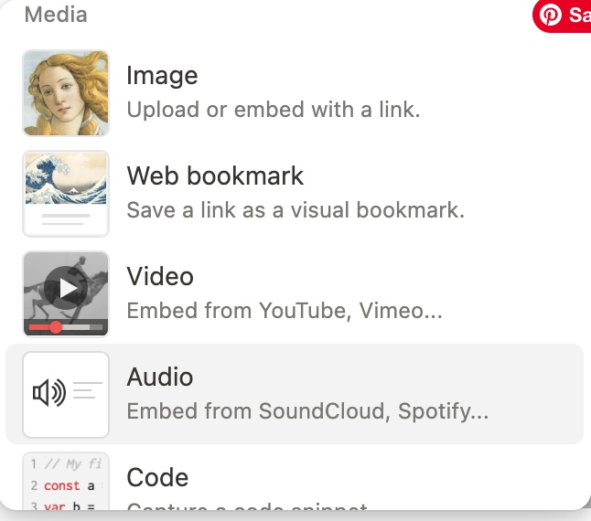  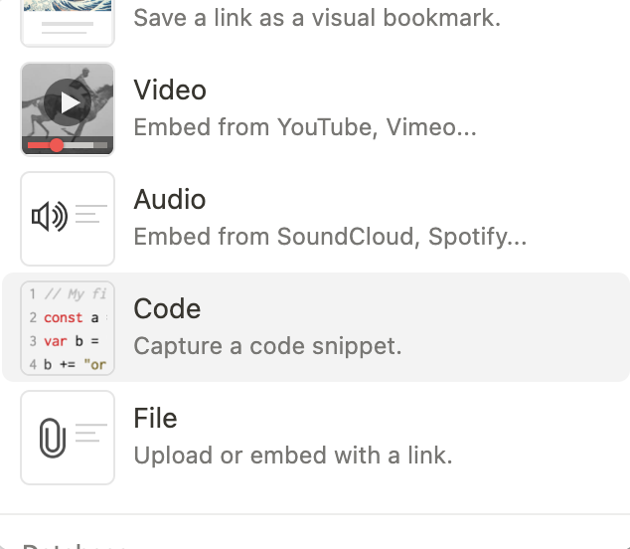  Notion – selecting from various types of files to upload

Appendix: There should be a separate feature allowing users to drag and drop uploaded images to the text editor. When deleting the image from the editor, no need to delete it from the source cards. The image should be automatically deleted from the document editor if deleted from the source cards. TBC

